Y1Q4W8

Elijah on Mt Carmel

Hangman: _ _ _ _ _
Say: In the last few Brisbane has had a big water shortage. – Read Brisbane history from printout.
Show: Show pictures of cloud seeding machines and explain.
Say: People think they're pretty smart these days, but their machines only work if there are already clouds.
Hangman: _ _ _ _
Ask: What are some different ways to start a fire?
Say: Today our story is about fire and water! – Those of you who were here last week will know some of it already, but today we are going to learn more about it and then do a page about it.

Bible Story

Sing Songs

Return to tables
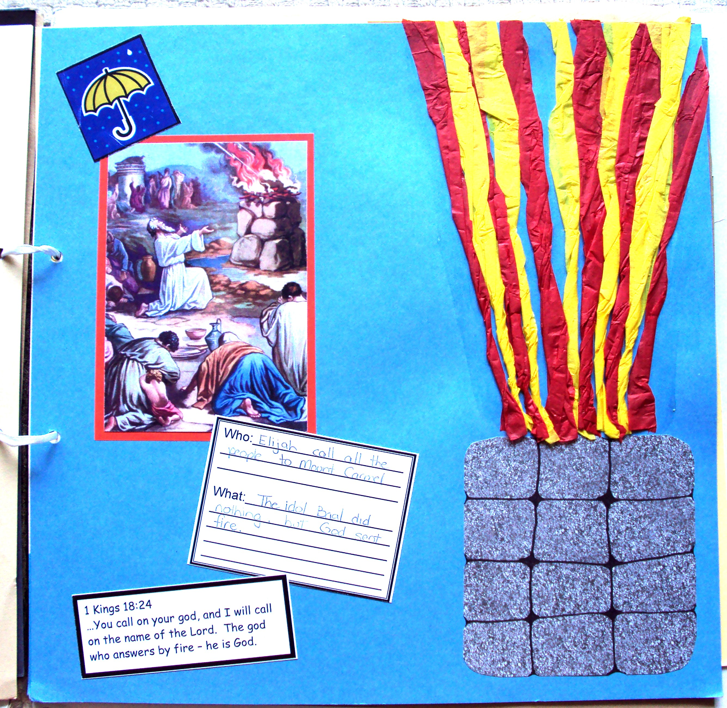
Memory Verse: Fill in the blanks and then say the memory verse on the colouring page.

Scrapbooks
- Choose a cardboard
- Stick on the altar and draw rocks on it
- Stick on the picture, umbrella, verse and description cards.
- Glue crepe paper for the fire.

Discuss the following depending on age, interest and time:
Can you think of any other Bible Stories where God controlled water? (Crossing Red Sea, Water from rock, walking on water)
Have you heard other stories about people not from the Bible where God controlled something? (There are many stories of God sending rain, or stopping a fire)
What other things can God control?
Does God still give people signs today? (Yes – Delwyn prayed that if she should buy the felt set to tell stories God would make it rain. It had been really sunny with no rain in ages and the next morning it was pouring – so she bought it.)
Have you ever seen a sign from God?
How can you check if a sign is from God? (See if it agrees with what the Bible says, ask God and talk to other people who love God)

Read the story ("The Idols Parade")

Ask: What can we do if we want a sunny day for a picnic or a rainy day for the garden?
Ask: Will God always give us what we ask for?
Say: Sometimes what we want is not the best thing, and then God won't give it to us, but if it is a good thing, then He will, and we can remember that He always wants the best things to happen for us.

Primary / Junior / Teen: This term, those of you who would like to get a Bible to take home, may take one of the orange Commandment pages and add to your book. Each week you come you can put a sticker on it and when it is all complete we will get you a Bible to take home and keep.

Finish with prayer.

